Name

- Define the following in your own words (you may use pictures to help your
explanation)
  - self-similarity

  - seed shape

  - scaling transformation

  - recursive (recursion)

  - iteration

  - fractal dimension

  - space-filling curve

  - scaling ratio

2. Please choose one of the shapes below. For that shape draw the next two iterations.

Iteration 2 Iteration 3

Describe how you went from the first to the second and the second to the third iterations

3. For each pair, write the letter of the sample with the higher fractal dimension. If they are the same, write same.
3.1
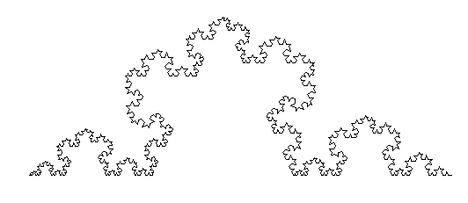  A. | 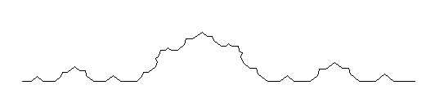  B. | Answer/Why
3.2
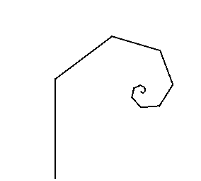  A. | 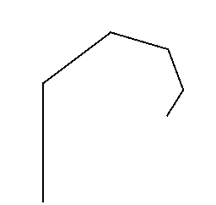  B. | Answer/Why

4. Name two reasons why evolution might produce fractals in organic structures.

1.

2.

5. Give an example of Fractals in engineering

6. Give an example of Fractals in Medicine

7. Give an example of Fractals in Culture

8. In many applications is it important for fractals to avoid self-intersection. Explain how to avoid it. You may use a sketch.

